Roll No-12

M.sc. 3rd semester

Date of Assignment-02/12/2020

Date of Submission-10/12/2020

**Experiment No -09**

**Topic**- Tracing the power curve for Normal distribution with unknown mean and variance

**Problem** – Consider the following sample from N(µ, $σ^{2}$) Where µ and $σ^{2}$ both are unknown. The sample values are 5.2,10.8,7.1,16.4,12.5,12,10.3,10.0,12.7,9.7,10.5

Construct the UMP test for testing h0:=4 against

1. h1:>4
2. h1:<4
3. h1:≠4

Also, draw the power curve for each of the cases considering the level of significance as α=0.05

**Theory and Calculation**-

(i)From the theory of similar region we know that the CR for testing h0:=4 against h1:>4is given by

where k1 is a constant to be determined in such a way that α=0.05

⸫ P

To, find the value of a1 we use the following R-command

a1=qchisq(0.95,10,0)

a1

⸫a1=18.30704

⸫k1=4a1=73.22815

We have**, $\overline{x}=10.654545$**

⸫ The S.R. is given by

$$W_{1}= \left\{\overset{̰}{X}: \sum_{i=1}^{n}{{(x_{i}-10.654545)}^{2}}>73.22815\right\}$$

Power of the test is given by

Power=1-β=P[xW1/H1]

Now, to trace the power curve we construct the following table considering different trial values of 2>4

**TABLE 1**

|  |  |  |
| --- | --- | --- |
| **Sl no** | **sigma_1** | **power_1** |
|  |  |  |
| **1** | 4.1 | 0.057362 |
| **2** | 4.2 | 0.06527 |
| **3** | 4.3 | 0.073707 |
| **4** | 4.4 | 0.082652 |
| **5** | 4.5 | 0.092082 |
| **6** | 4.6 | 0.10197 |
| **7** | 4.7 | 0.112289 |
| **8** | 4.8 | 0.123008 |
| **9** | 4.9 | 0.134098 |
| **10** | 5 | 0.145526 |
| **11** | 5.1 | 0.15726 |
| **12** | 5.2 | 0.169269 |
| **13** | 5.3 | 0.181521 |
| **14** | 5.4 | 0.193985 |
| **15** | 5.5 | 0.206631 |
| **16** | 5.6 | 0.219428 |
| **17** | 5.7 | 0.23235 |
| **18** | 5.8 | 0.245368 |
| **19** | 5.9 | 0.258456 |
| **20** | 6 | 0.271591 |
| **21** | 6.1 | 0.284748 |
| **22** | 6.2 | 0.297905 |
| **23** | 6.3 | 0.311043 |
| **24** | 6.4 | 0.324141 |
| **25** | 6.5 | 0.337183 |
| **26** | 6.6 | 0.350151 |
| **27** | 6.7 | 0.363031 |
| **28** | 6.8 | 0.375808 |
| **29** | 6.9 | 0.388471 |
| **30** | 7 | 0.401007 |

**Programming in R for case 1-**

library('ggplot2')

k_1 = 73.22815

sigma_1 = seq(from=4.1, by=0.1, length.out=30)

sigma_1

sigma_11 = k_1/sigma_1

sigma_11

power_1 = mat.or.vec(30,1)

for(i in 1:30){

power_1[i] = 1-pchisq(sigma_11[i],10,0)

}

power_1

Table = data.frame(sigma_1, power_1)

Table

View(Table)

ggplot(data = Table, mapping = aes(x = sigma_1,y = power_1))+geom_point()+geom_line()

data.frame(sigma_1)

data.frame(power_1)

**Power curve by using ggplot 2**

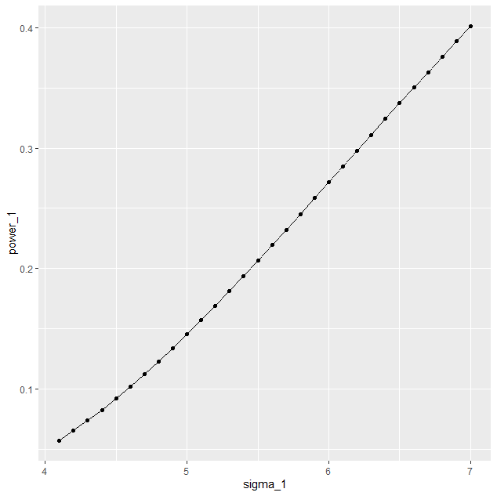

**Power curve generated by using Tableau**

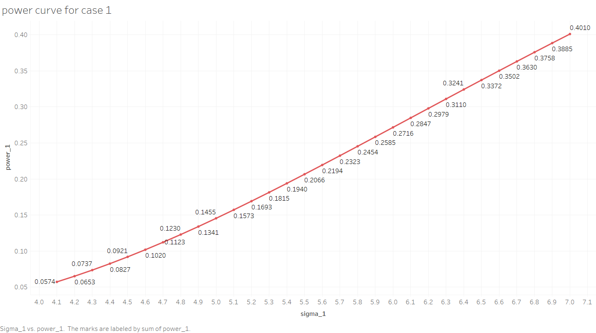

ii) To test h1:=4against h1:<4, is given by

where k2 is a constant to be determined in such a way that α=0.05

⸫ P

To, find the value of a2 we use the following R-command,

a2=qchisq(0.05,10,0)

a2

⸫a2=3.940299

So,k2=15.7612

⸫The similar region is given by

$$W_{2}= \left\{\overset{̰}{X}: \sum_{i=1}^{11}{{(x_{i}-10.654545)}^{2}}<15.7612\right\}$$

The power of the test is given by

1-β=P(xW2/H1)

=P[Reject H0/H1 is true]

$$=P\left[\sum_{i=1}^{n}{{\left(x_{i}-10.654545\right)}^{2}<15.7612/H_{1}}\right]$$

$=P\left[χ_{10}^{2}<\frac{15.7612}{σ_{1}^{2}}\right]$

$$=1-P\left[χ_{10}^{2}>\frac{73.22815}{σ_{1}^{2}}\right]$$

To draw the power curve we construct the following table considering different trial values of $σ<4$

**TABLE 2**

|  |  |  |
| --- | --- | --- |
| **sl no** | **sigma_2** | **power_2** |
|  |  |  |
| **1** | 1 | 0.893325 |
| **2** | 1.1 | 0.841466 |
| **3** | 1.2 | 0.783742 |
| **4** | 1.3 | 0.723157 |
| **5** | 1.4 | 0.662226 |
| **6** | 1.5 | 0.602846 |
| **7** | 1.6 | 0.546316 |
| **8** | 1.7 | 0.493435 |
| **9** | 1.8 | 0.444615 |
| **10** | 1.9 | 0.39999 |
| **11** | 2 | 0.359501 |
| **12** | 2.1 | 0.322969 |
| **13** | 2.2 | 0.29014 |
| **14** | 2.3 | 0.260726 |
| **15** | 2.4 | 0.234423 |
| **16** | 2.5 | 0.210934 |
| **17** | 2.6 | 0.189972 |
| **18** | 2.7 | 0.171273 |
| **19** | 2.8 | 0.154589 |
| **20** | 2.9 | 0.1397 |
| **21** | 3 | 0.126403 |
| **22** | 3.1 | 0.114521 |
| **23** | 3.2 | 0.103893 |
| **24** | 3.3 | 0.094377 |
| **25** | 3.4 | 0.085848 |
| **26** | 3.5 | 0.078194 |
| **27** | 3.6 | 0.071318 |
| **28** | 3.7 | 0.065132 |
| **29** | 3.8 | 0.059561 |
| **30** | 3.9 | 0.054537 |

**Programming in R for case 2-**

library('ggplot2')

k_2 = 15.7612

sigma_2 = seq(from=1.0, by=0.1, length.out=30)

sigma_2

sigma_22 = k_2/sigma_2

sigma_22

power_2 = mat.or.vec(30,1)

for(i in 1:30){

power_2[i] = pchisq(sigma_22[i],10,0)

}

power_2

Table = data.frame(sigma_2, power_2)

Table

View(Table)

ggplot(data = Table, mapping=aes(x = sigma_2, y = power_2))+geom_point()+geom_line()

data.frame(sigma_2)

data.frame(power_2)

**Power curve by using ggplot 2**

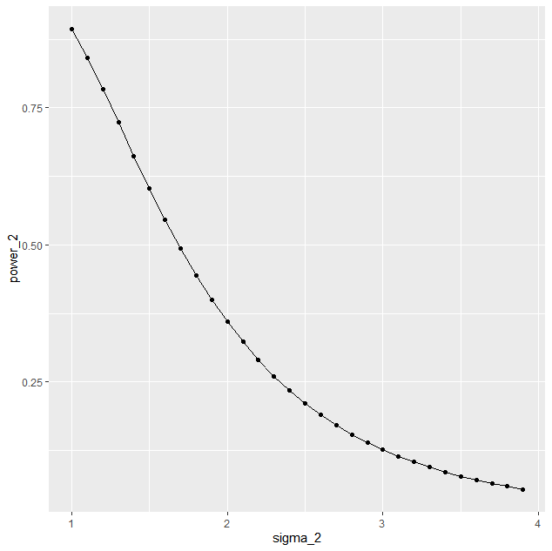

**Power curve generated by using Tableau**

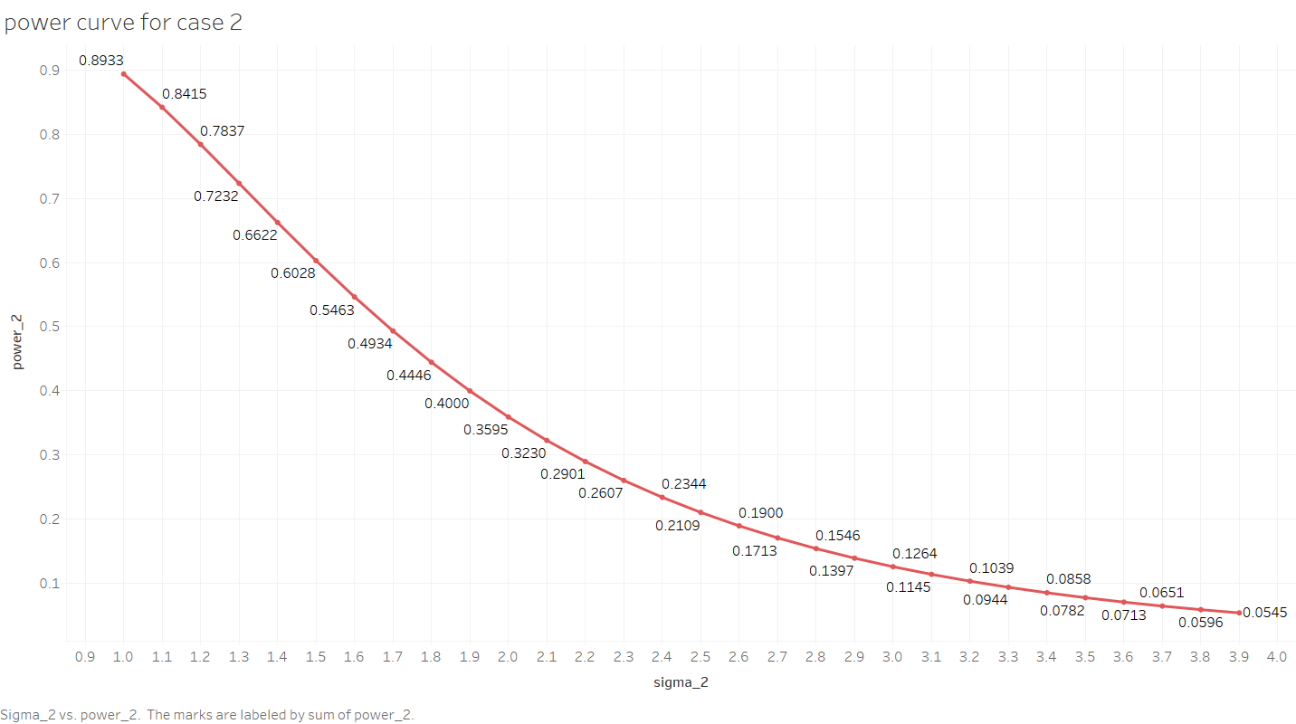

(iii)To test H0:=4against H1:≠4 , the best similar region is given by

$$W_{3}= \left\{\overset{̰}{X}: \sum_{i=1}^{11}{{{(x}_{i}-\overline{x})}^{2}<k_{3}}\right\} or\left\{\overset{̰}{X}: \sum_{i=1}^{11}{{{(x}_{i}-\overline{x})}^{2}>k_{4}}\right\}$$

Where, k3 and k4 are constants to be determined such that α=0.05

⸫ P $\left[x∈W_{3}|H_{0}\right]=0.05$

$$⇒P\left[\sum_{i=1}^{11}{{\left(x_{i}-\overline{x}\right)}^{2}}<k_{3}|H_{0} or\sum_{i=1}^{11}{{\left(x_{i}-\overline{x}\right)}^{2}}>k_{4}|H_{0}\right]=0.05$$

Assuming that the test is equitailed, we have

$$⇒P\left[\sum_{i=1}^{11}{\frac{{\left(x_{i}-\overline{x}\right)}^{2}}{σ_{0}^{2}}}<\frac{k_{3}}{σ_{0}^{2}}\right]=\frac{0.05}{2}$$

$$\&P\left[\sum_{i=1}^{11}{\frac{{\left(x_{i}-\overline{x}\right)}^{2}}{σ_{0}^{2}}}>\frac{k_{4}}{σ_{0}^{2}}\right]=\frac{0.05}{2}$$

$⇒P\left[χ_{10}^{2}<a_{3}\right]=0.025$

& $P\left[χ_{10}^{2}>a_{4}\right]=0.025$

Where, a3= = and a4= =

Now to determine the values of a3 and a4 we use the following R-command:

a3=qchisq(0.025,10,0)

a3

a4=qchisq(0.975,10,0)

a4

⸫a3=3.246973 and a4=20.48318

⸫k3=12.98789 and k4=81.93271

Also , $\overline{x}=10.654545$

⸫The similar region is given by

$$W_{3}= \left\{\overset{̰}{X}: \sum_{i=1}^{11}{{{(x}_{i}-\overline{x})}^{2}<12.98789}\right\} or \left\{\overset{̰}{X}: \sum_{i=1}^{11}{{{(x}_{i}-\overline{x})}^{2}>81.93271}\right\}$$

Now, Power of the test is given by

1-β=P(xW3/H1)

=P[Reject H0/H1 is true]

$$=P\left[\frac{\sum_{i=1}^{n}{{(x_{i}-10.654545)}^{2}}}{σ_{1}^{2}}<\frac{12.98789}{σ_{1}^{2}}or\frac{\sum_{i=1}^{n}{{{(x}_{i}-10.654545)}^{2}}}{σ_{1}^{2}}>\frac{81.93271}{σ_{1}^{2}}\right]$$

$=P\left[χ_{10}^{2}<\frac{12.98789}{σ_{1}^{2}}\right]+P\left[χ_{10}^{2}>\frac{81.93271}{σ_{1}^{2}}\right]$

$=P\left[χ_{10}^{2}<\frac{12.98789}{σ_{1}^{2}}\right]+1-P\left[χ_{10}^{2}<\frac{81.93271}{σ_{1}^{2}}\right]$

To trace the power curve we construct the following table considering different trial values of 2

**TABLE 3**

|  |  |  |
| --- | --- | --- |
| **sl no** | **sigma_3** | **power_3** |
|  |  |  |
| **1** | 4.1 | 0.052213 |
| **2** | 4.2 | 0.055101 |
| **3** | 4.3 | 0.058642 |
| **4** | 4.4 | 0.062812 |
| **5** | 4.5 | 0.06759 |
| **6** | 4.6 | 0.07295 |
| **7** | 4.7 | 0.078868 |
| **8** | 4.8 | 0.085319 |
| **9** | 4.9 | 0.092276 |
| **10** | 5 | 0.099713 |
| **11** | 5.1 | 0.107602 |
| **12** | 5.2 | 0.115915 |
| **13** | 5.3 | 0.124625 |
| **14** | 5.4 | 0.133704 |
| **15** | 5.5 | 0.143123 |
| **16** | 5.6 | 0.152856 |
| **17** | 5.7 | 0.162874 |
| **18** | 5.8 | 0.173152 |
| **19** | 5.9 | 0.183662 |
| **20** | 6 | 0.19438 |
| **21** | 6.1 | 0.205281 |
| **22** | 6.2 | 0.21634 |
| **23** | 6.3 | 0.227536 |
| **24** | 6.4 | 0.238845 |
| **25** | 6.5 | 0.250246 |
| **26** | 6.6 | 0.26172 |
| **27** | 6.7 | 0.273248 |
| **28** | 6.8 | 0.284811 |
| **29** | 6.9 | 0.296392 |
| **30** | 7 | 0.307975 |
| **31** | 1 | 0.77565 |
| **32** | 1.1 | 0.701831 |
| **33** | 1.2 | 0.628546 |
| **34** | 1.3 | 0.558689 |
| **35** | 1.4 | 0.493973 |
| **36** | 1.5 | 0.435219 |
| **37** | 1.6 | 0.382633 |
| **38** | 1.7 | 0.33604 |
| **39** | 1.8 | 0.295045 |
| **40** | 1.9 | 0.259148 |
| **41** | 2 | 0.227813 |
| **42** | 2.1 | 0.200512 |
| **43** | 2.2 | 0.176754 |
| **44** | 2.3 | 0.156093 |
| **45** | 2.4 | 0.138133 |
| **46** | 2.5 | 0.122532 |
| **47** | 2.6 | 0.108994 |
| **48** | 2.7 | 0.097269 |
| **49** | 2.8 | 0.087149 |
| **50** | 2.9 | 0.078458 |
| **51** | 3 | 0.071053 |
| **52** | 3.1 | 0.064816 |
| **53** | 3.2 | 0.059652 |
| **54** | 3.3 | 0.055481 |
| **55** | 3.4 | 0.052242 |
| **56** | 3.5 | 0.049882 |
| **57** | 3.6 | 0.048359 |
| **58** | 3.7 | 0.047638 |
| **59** | 3.8 | 0.047689 |
| **60** | 3.9 | 0.048484 |

**Programming in R for case 3-**

library('ggplot2')

k_3 = 12.98789

k_4 = 81.93271

sigma_1 = seq(from=4.1, by=0.1, length.out=30)

sigma_1

sigma_2 = seq(from=1.0, by=0.1, length.out=30)

sigma_2

sigma_3 = c(sigma_1,sigma_2)

sigma_3

sigma_31 = k_3/sigma_3

sigma_31

sigma_32 = k_4/sigma_3

sigma_32

power_3 = mat.or.vec(60,1)

for(i in 1:60){

power_3[i] = pchisq(sigma_31[i],10,0)+1-pchisq(sigma_32[i],10,0)

}

power_3

Table = data.frame(sigma_3, power_3)

Table

View(Table)

ggplot(data = Table, mapping = aes(x = sigma_3, y = power_3))+geom_point()+geom_line()

data.frame(sigma_3)

data.frame(power_3)

**Power curve by using ggplot 2**

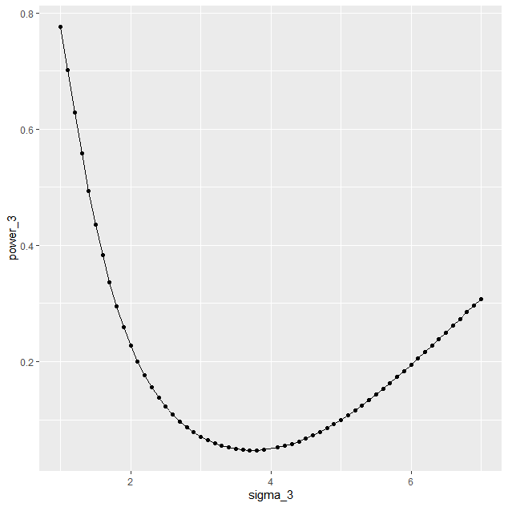

**Power curve generated by using Tableau**

